Table of Contents

**AI Vs ML vs DL vs Data Science2**

**Machine Learning and Deep Learning3**

**Regression And Classification**4

**Linear Regression Algorithm**

**Ridge And Lasso Regression Algorithms**

**Logistic Regression Algorithm**

**Linear Regression Practical Implementation**

**Ridge And Lasso Regression Practical Implementation**

**Naive Baye's Algorithms**

**KNN Algorithm Intuition**

**Decision Tree Classification Algorithms**

**Decision Tree Regression Algorithms**

**Practical Implementation Of Decision Tree Classifier**

**Ensemble Bagging and Boosting Techniques**

**Random Forest Classifier and Regressor**

**Boosting, Adaboost Machine Learning Algorithms**

**K Means Clustering Algorithm…………………………………………………………………………………………**

**Hierarichal Clustering Algorithms**

**Silhoutte Clustering- Validating Clusters**

**Dbscan Clustering Algorithms**

**Clustering Practical Examples**

**Bias And Variance Algorithms**

**Xgboost Classifier Algorithms**

**Xgboost Regressor Algorithms**

**SVM Algorithm Machine LEarning Algorithm**

AI VS ML VS DL

Machine learning is basically subset of AI

* ML basically gives you stats tool to analyze visualizing , predicting and forcasting

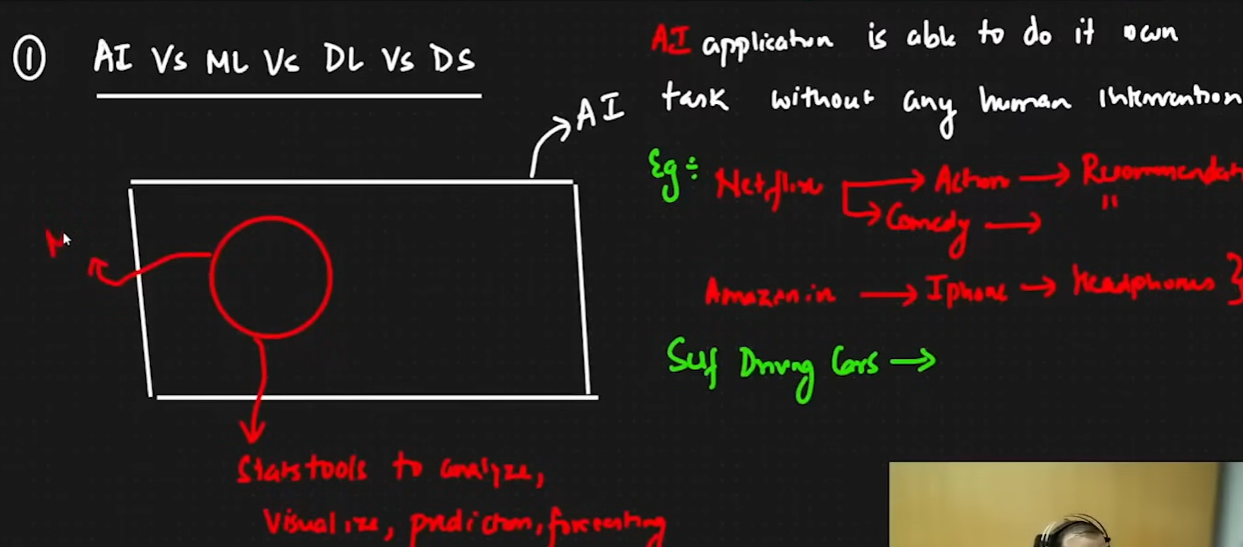

* The goal is to create an AI application

MACHINE LEARNING AND DEEP LEARNING



Two algorithm

Supervised ML

Unsupervised ML

|  |  |
| --- | --- |
| Supervised ML   * Regression Problem * Classification Problem | Unsupervised ML   * Clustering * Dimensionality reduction |

Note: There is also one more time which is called reinforcement learning

|  |  |
| --- | --- |
| Age | Weight |
| 24 | 62 |
| 25 | 63 |
| 21 | 72 |
| 27 | 62 |

Supervised ML Example of a data set :

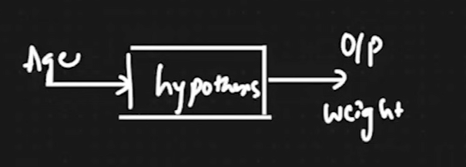

* INDEPENDENT FEATURE (
  + AGE
* DEPENDENT GEATURE
  + Weight

The value of weight is changing according to age so that’s why they are categorized as dependent and independent

Regression vs Classification

Regression

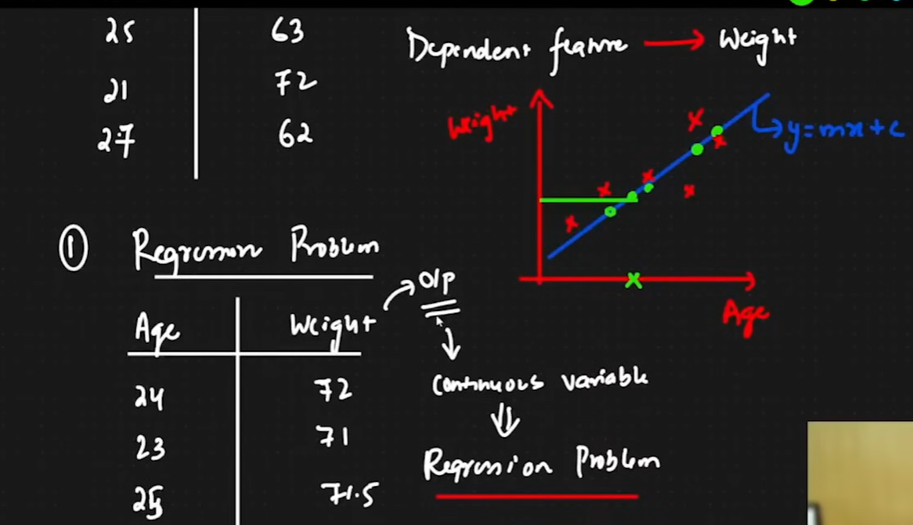

* In regression there will be outputs of continuous variable

CLASSIFICATION

|  |  |  |  |
| --- | --- | --- | --- |
| No of hrs | No of play hrs | No of sleep | Pass or Fail(dependent geature) AKA Putput |
| - | - | - | P |
| - | - | - | F |

Classification : whenever you have fixed number of categorical output it becomes a classification output

Binary Classification: There are two categories of output Example P/F

Multi class classification: Multiple categories of output

Unsupervised ML

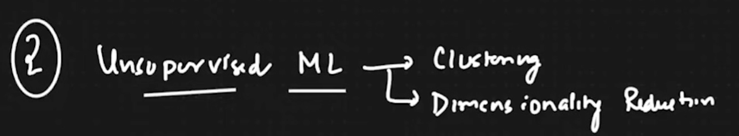

|  |  |  |
| --- | --- | --- |
| Salary | Age | No dependent variable |
| - | - |  |
| - | - |  |

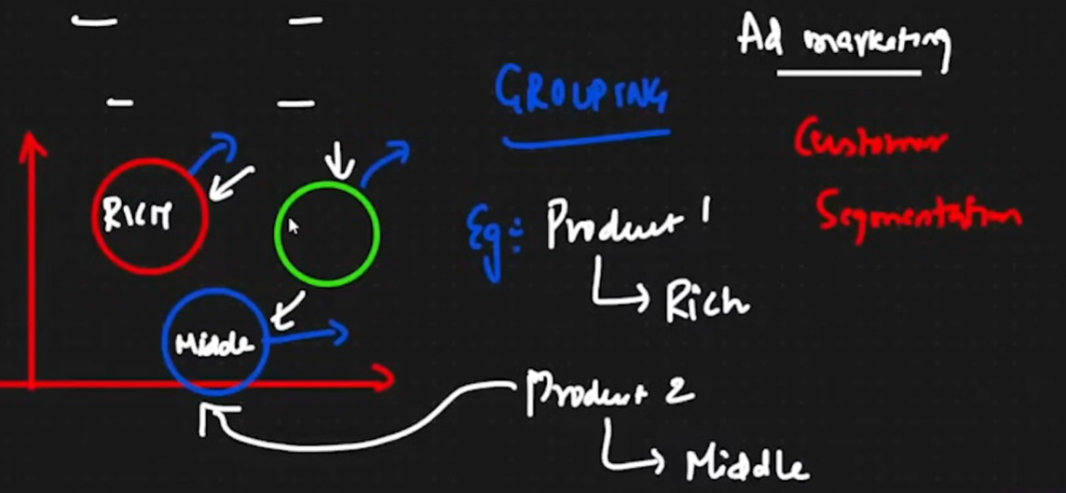

* Clustering
  + Grouping
    - Example for Ad marketing : Product 1 for rich people product 2 for poor people etc

Dimensionality Reduction

Lower 100 feature of 100 feature examples of that is PCA and LDA

| **Supervised Learning Algorithms** | **Unsupervised Learning Algorithms** |
| --- | --- |
| 1. Linear Regression | 1. K-Means |
| 2. Ridge & Lasso | 2. DBSCAN |
| 3. Logistic Regression | 3. Hierarchical Clustering |
| 4. Decision Tree | 4. K-Nearest Neighbor (Clustering) |
| 5. AdaBoost | 5. PCA (Principal Component Analysis) |
| 6. Random Forest | 6. LDA (Linear Discriminant Analysis) |
| 7. Gradient Boosting |  |
| 8. XGBoost |  |
| 9. Naive Bayes |  |

**Linear Regression**

Find out the best fit line which will actually help in making prediction

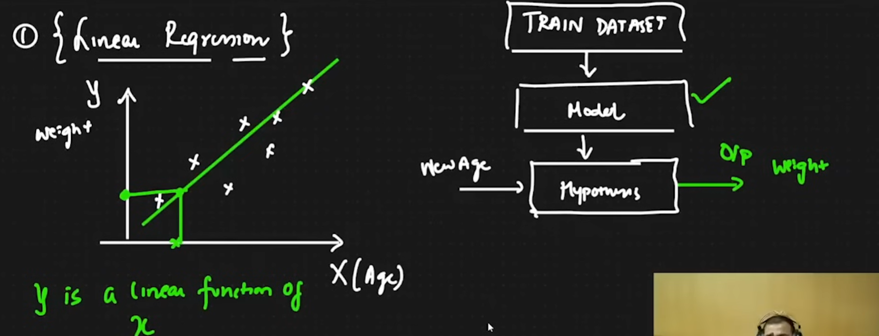

Y is a linear function of X

The line equation could be given as:

Y=mx+c

Y=B0+B1x

H(x) = theta0 +theta1x

Etc

This is the best fit line eqn : theta0 is the intercept when x=0   


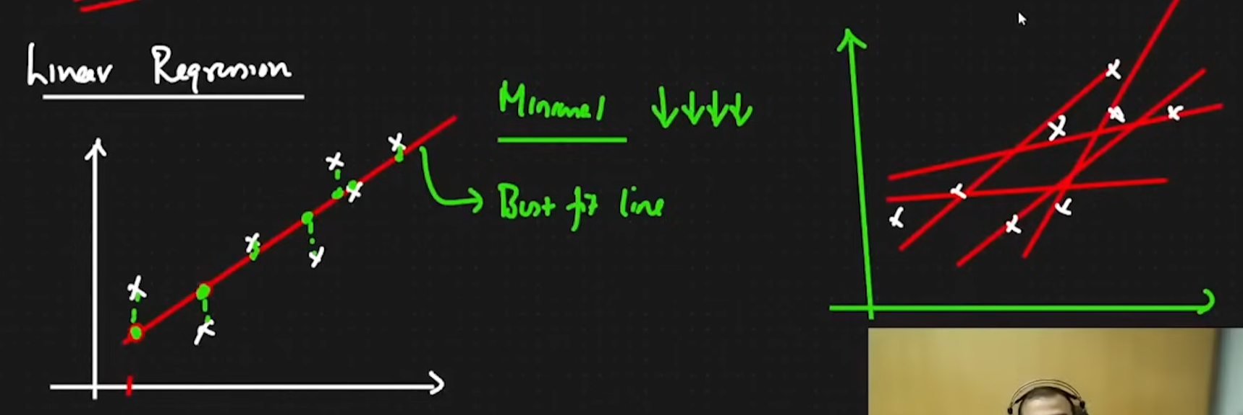

Our aim is to find the minimal cost line and to create a cost function The best red line possible

The distance in the submission should be minimal see the green lines

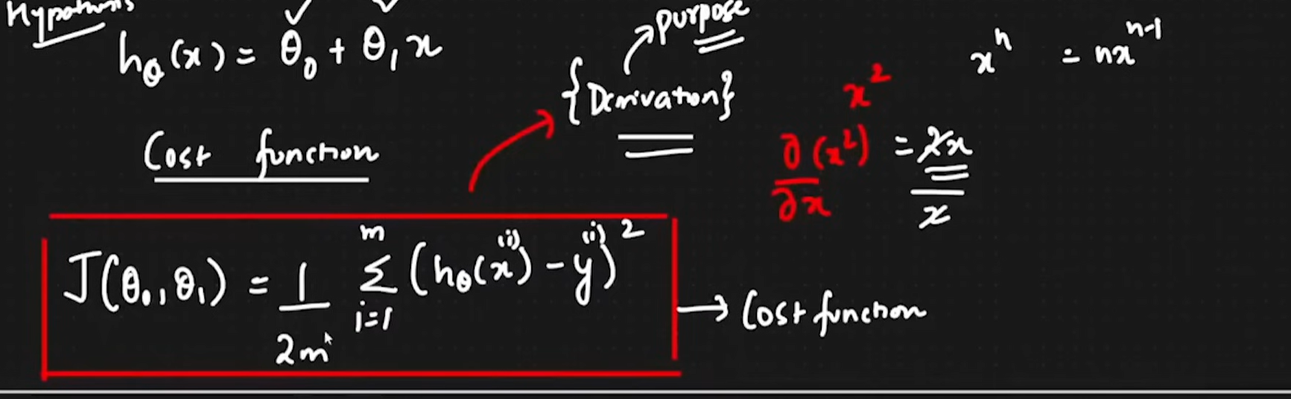

The entire equation is called as Squared error function, squaring is done to discard negative values

And m is the total number of points being compared, it is divided to get an average. It is divided by 2 for simplicity of mathematical equation

Time:30:00

What we need to actually solve

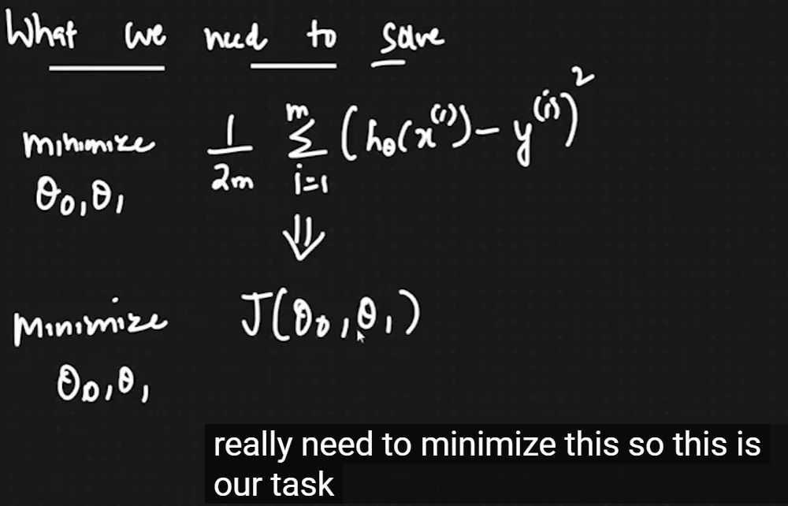

We need to make sure that we get the right theta 1 value

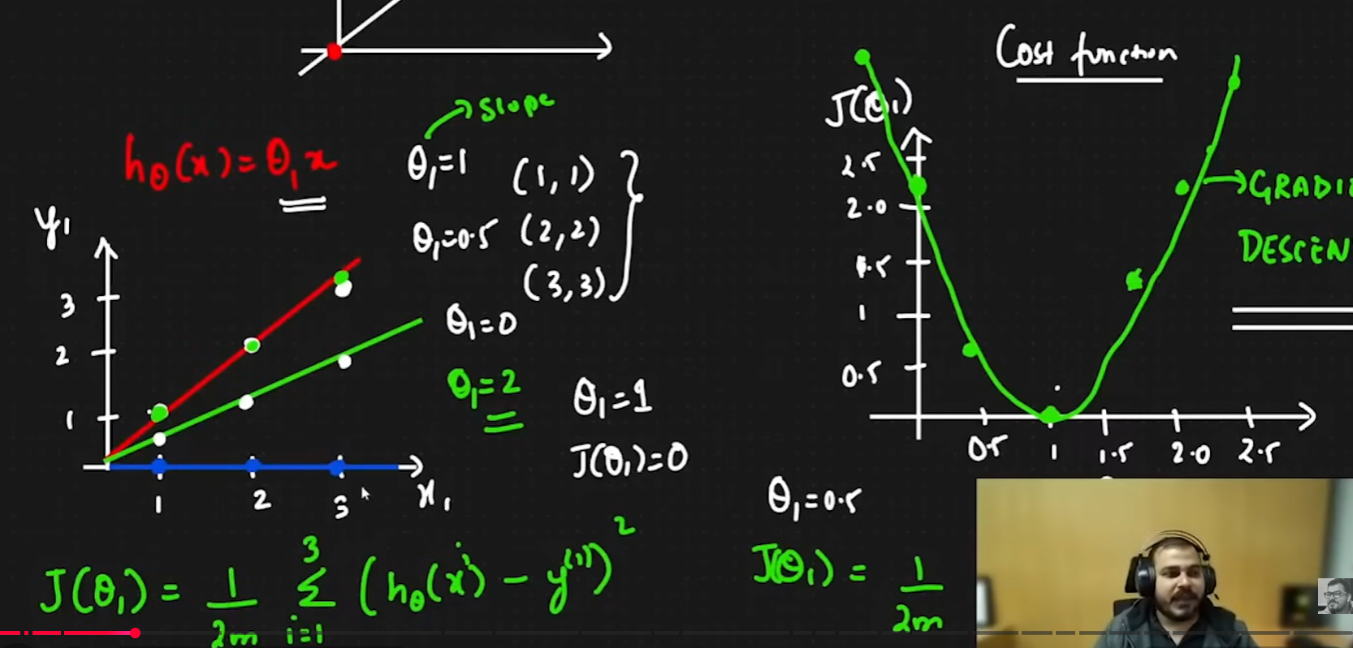

.

The best fit line represents global minimum

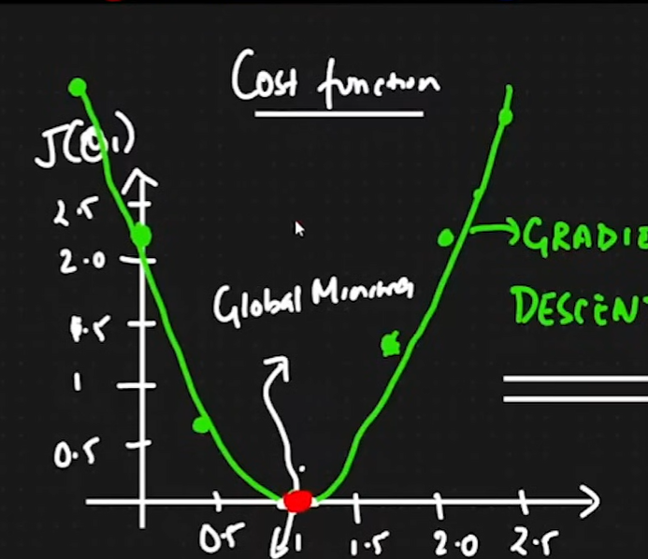

We need to try to find the red dot in the parabola that is in the upper section which can help us get to the global minimum

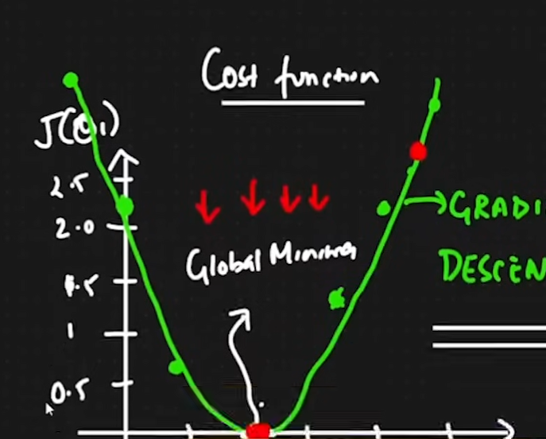

The Convergence Algorithm needs to be used to get to the

global minimum

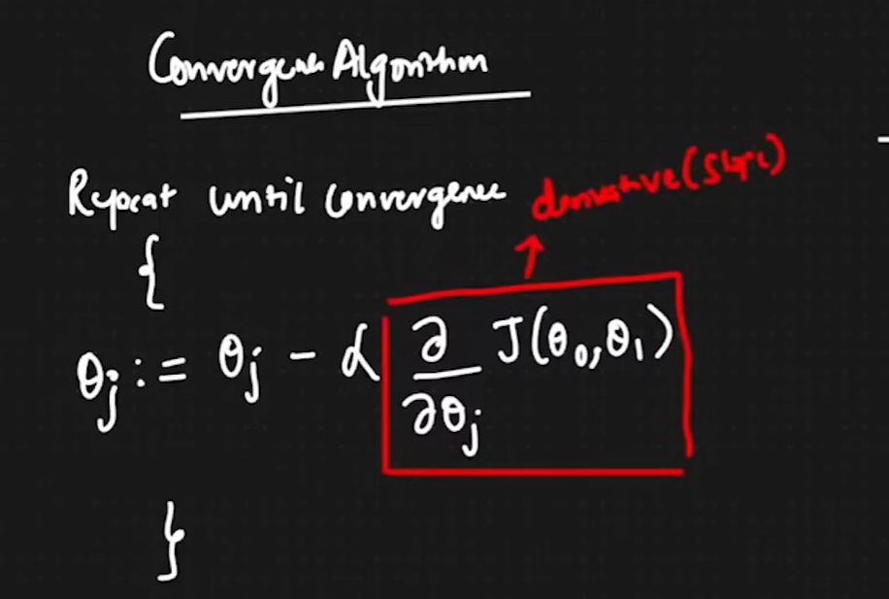

How does it find itself ?  
if we find the point in right hand side of the parabola or the right side of the parabola the formula will adjust itself relatively and also if the point is on the left side it will adjust accordingly .

Also we need to choose our alpha very carefully so that the points never reach the global minimum 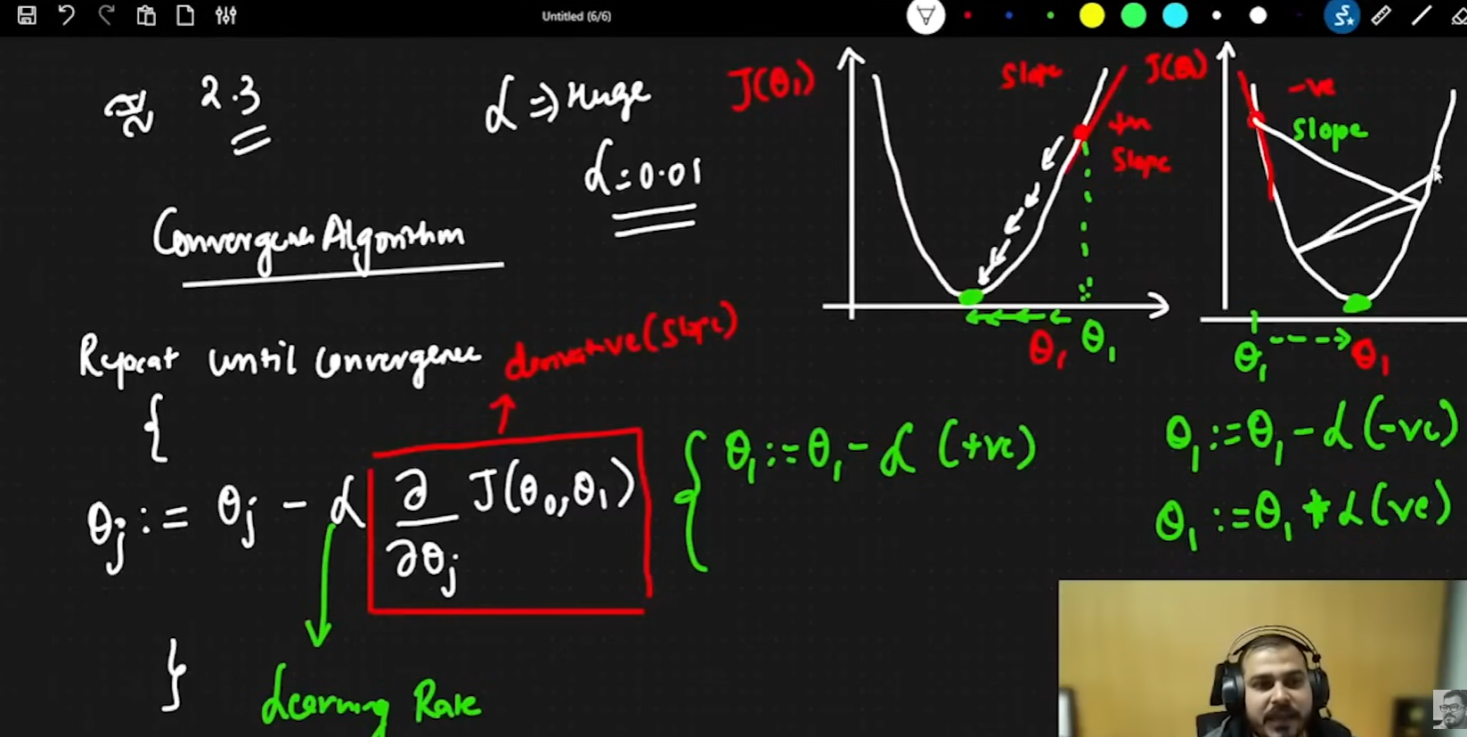

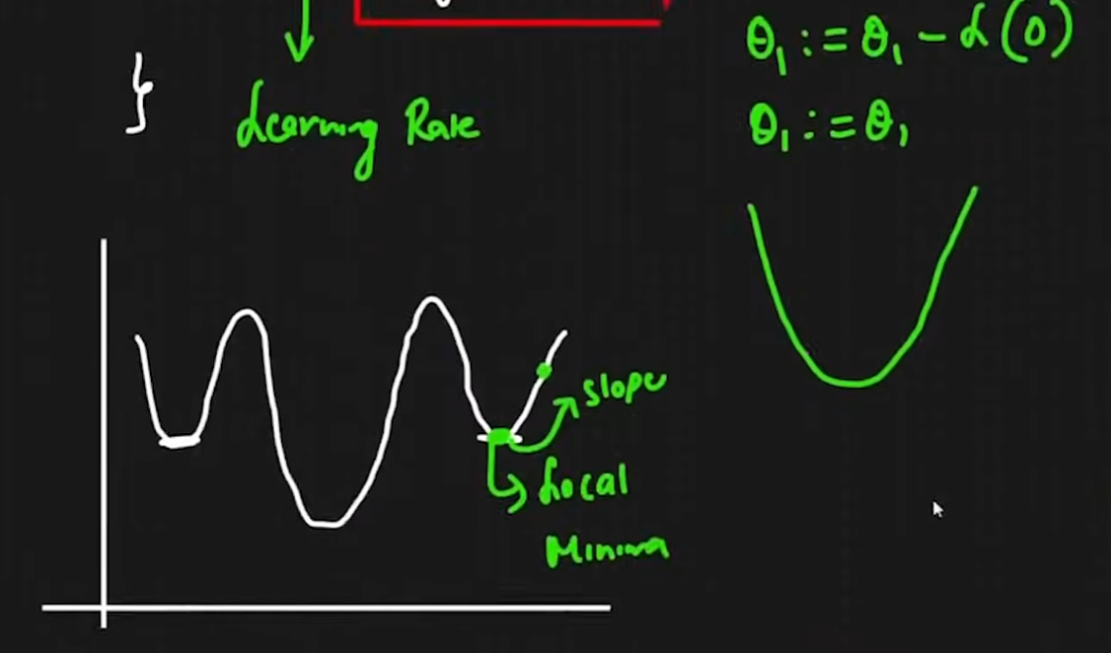

In some cases we can get the local minimum as the actual point, but this problem is not solved in linear regression and this could be solved using deep learning algorithms, Gradiennt descent and ANN in dl has lot of local dinima adam optimizers are used in such cases.

Gradient decent algorithm

Repeat until convergence

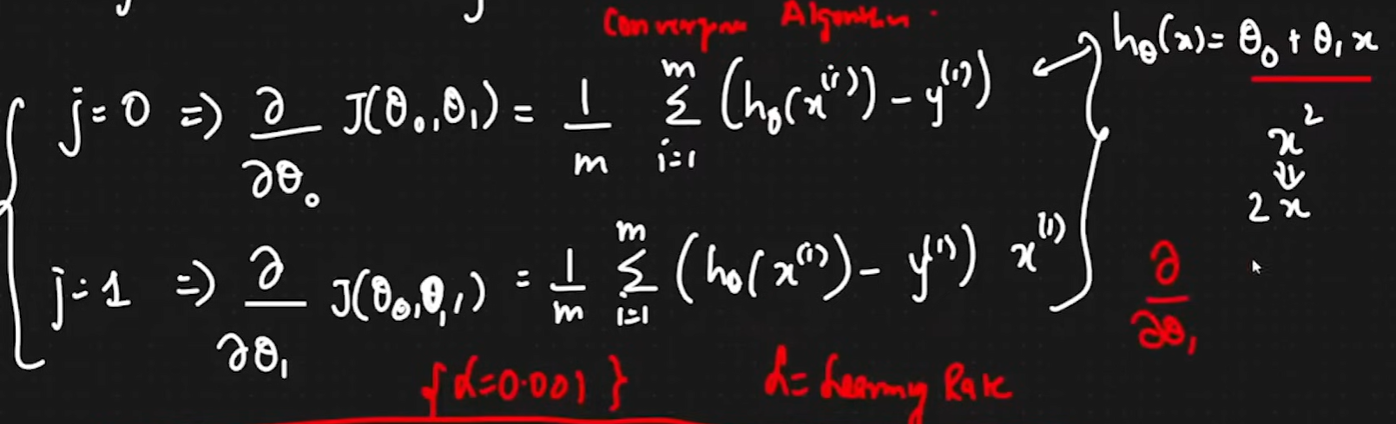

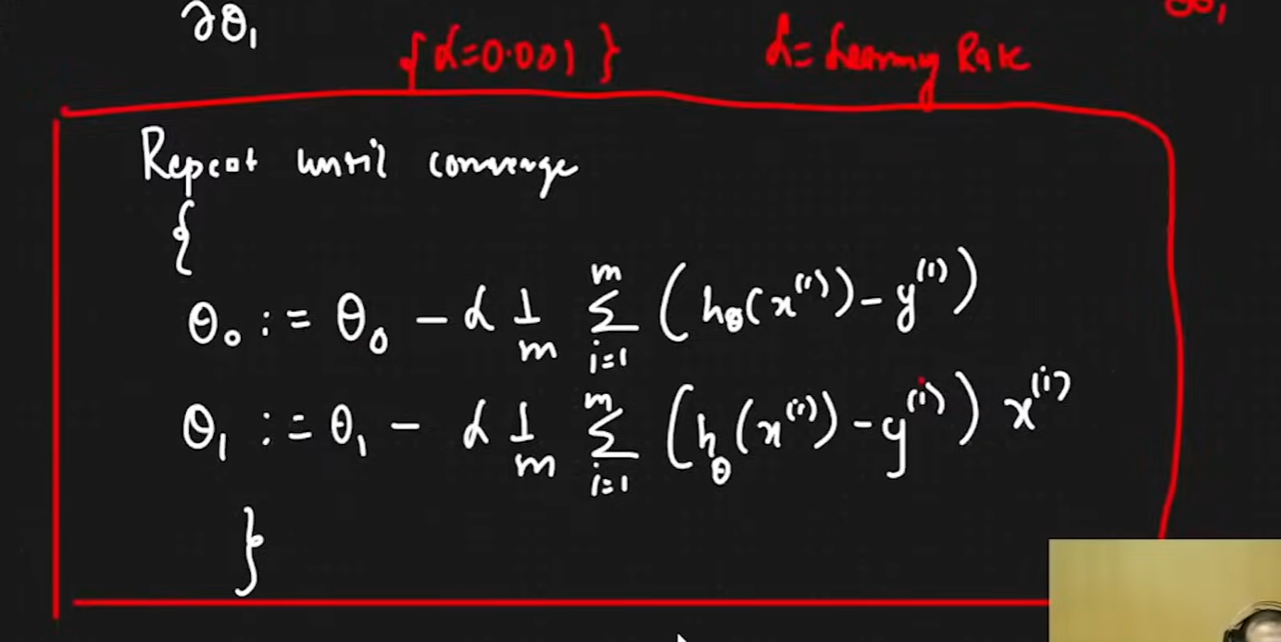

55:08